CPS 510 - Database Systems I
Group 8
Assignment - 10

Amartya Chowdhury, 501153217
Mehrin Afroz Eshana, 501147157
Mohamad Al Walied Hasan Nafis, 501241332

Introduction
This project builds a working database system for a retail clothing store. The goal is to manage customers, products, orders, payments, categories, and related operations. The project covers database design, normalization, SQL implementation, query development, and a user interface. The final design supports clean data storage, reliable transactions, and useful reports for decision-making.

Business nature of the database
The store sells clothing items in several categories. Customers place orders. Each order includes products. Payments record how the order was paid. Managers use the system to track revenue, find missing payments, view product demand, and identify patterns in customer activity. The database helps the store track sales and supports reporting tasks such as top products, category revenue, and customer purchase behaviour across months.

Conceptual design, ER and EER
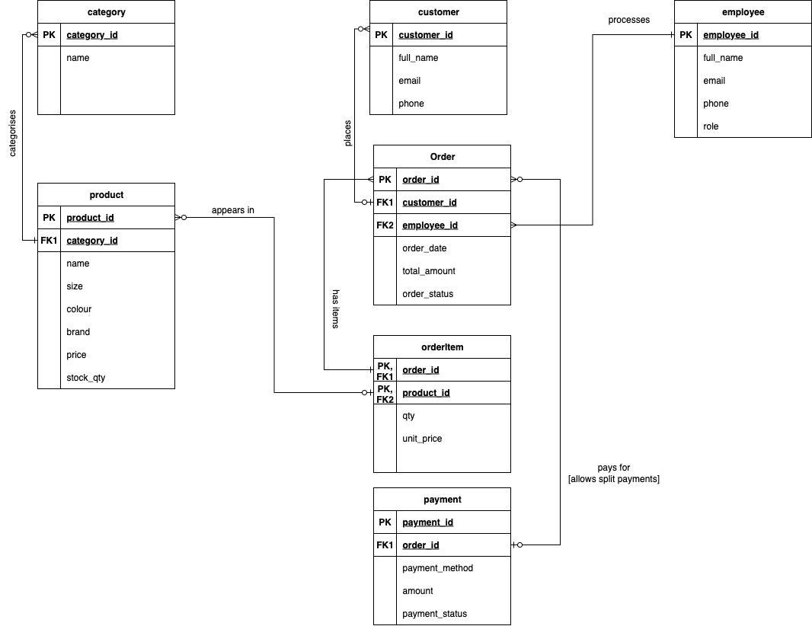
The conceptual design defines the structure of the system at a high level. The main entities include:

Customer
Attributes: customer_id, first_name, last_name, email
Each customer places zero or more orders.

Product
Attributes: product_id, product_name, price, category_id
Products belong to exactly one category.

Category
Attributes: category_id, category_name
Each category contains zero or more products.

Order
Attributes: order_id, order_date, order_status, customer_id, total_amount
Each order belongs to exactly one customer.

OrderItem
Composite entity connecting orders and products.
Attributes: order_id, product_id, quantity, item_price

Payment
Attributes: payment_id, order_id, payment_date, status, amount
Each payment belongs to a single order.

Relationships
Customer to Order: one to many.
Order to OrderItem: one to many.
Product to OrderItem: one to many.
Category to Product: one to many.
Order to Payment: one to many.

The EER model adds business rules such as payment status and the link between order items and revenue.

Internal design, SQL
The internal design defines how the conceptual model becomes SQL tables.

Tables
We created tables for:
Customer, Category, Product, Order, OrderItem, Payment.

Keys
Each table has a primary key.
Foreign keys connect related tables.
OrderItem uses a composite primary key of order_id and product_id.

Constraints
Not null and check constraints enforce valid prices, quantities, statuses, and order totals.

Sequences
We created sequences for product_id, order_id, payment_id, and customer_id where needed.

Triggers
Triggers assign sequence values on insert.
These automate key generation and keep the data consistent.

Data insertion
Sample data simulates retail activity across two months.
The data supports advanced queries such as top products and missing payments.

Normalization, 1NF to 3NF and BCNF
The schema satisfies standard normalization rules.

1NF
Each table has atomic values.
No repeating groups.
No multi-valued attributes.

2NF
Every non-key attribute depends on the full key.
OrderItem uses a composite key.
item_price and quantity depend on the entire key.
No partial dependencies remain.

3NF
No transitive dependencies.
Product price depends only on product_id.
Customer name depends only on customer_id.
Order status depends only on order_id.
All transitive dependencies were removed in earlier assignments.

BCNF
All tables satisfy BCNF.
Every determinant is a key.
No table required further decomposition.
Our A8 work verified each relation and confirmed that the final schema meets BCNF.

Relational Algebra, queries from Assignments 4 and 5
Below are the RA expressions for the important queries.

Q1, top products by revenue
Revenue = sum(quantity * item_price).
Join OrderItem with Product.
Group by product_id.
Project product_name and revenue.

π product_name, sum(item_price * quantity)(OrderItem ⋈ Product)

Q2, orders with no payment
Select orders where no PAID row exists.

σ(status ≠ ‘PAID’)(Order ⋉ Payment)

Q3, category revenue greater than threshold
Join Category, Product, OrderItem.
Group by category_id.
Select revenue sums greater than input.

σ(revenue > THRESH)(π category_name, sum(item_price * quantity)(Category ⋈ Product ⋈ OrderItem))

Q4, products never ordered
All products minus products in OrderItem.

π product_id, product_name(Product)
−
π product_id, product_name(Product ⋈ OrderItem)

Q5, customers who purchased in both month A and month B
Intersect sets of customers who made purchases in month A and month B.

(π customer_id σ(month = A)(Order))
∩
(π customer_id σ(month = B)(Order))

Q6, orders with no payment row
Left join Order with Payment and select null matches.

σ(payment_id is null)(Order ⋉ Payment)

Future development
Planned improvements:
- Add discount rules and coupons
- Add inventory tracking (partially implemented)
- Add a manager dashboard
- Add better reporting and analytics
- Add user authentication for staff
- Add search filters for products and orders
- Store historical logs for auditing
- Move the system to cloud hosting if needed
- Provide mobile UI access for staff

Conclusion
- The project produced a full database system for a retail store.
- The schema follows a clean conceptual design, strong SQL structure, and full normalization.
- Queries provide insight into revenue, missing payments, and customer activity.
- The system can grow with more features and supports clear future expansion.

References
- CPS510 lecture slides
- CPS510 assignment handouts
- Oracle 11g documentation
- SQL Developer user guide
- Java JDBC template from course materials
- Django and PHP connection notes from Instructor

